( 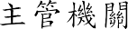)
10
50

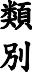 | ( 10 )  (  50 )
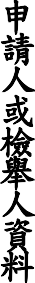 | 1 | 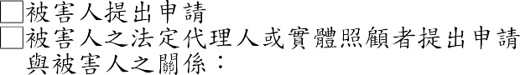 |  |  |  |  | 2
 | 3
 | 3 |  |  | 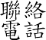 |  | 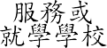
 | 3 |  | 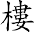
 |  |  | 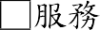
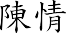
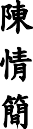

( ) 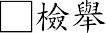

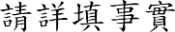 ( 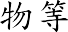) 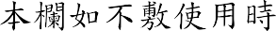
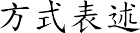
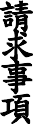
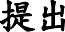
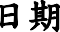
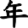
/ /
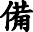 | 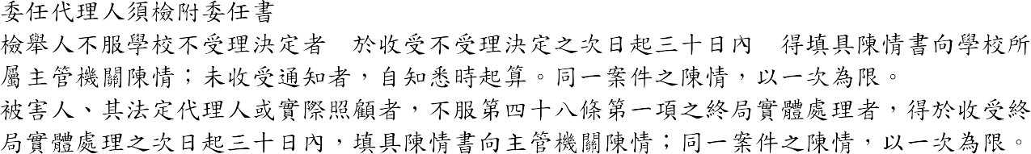  1.  2.  3.

