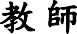







 |  |  |  |  | 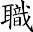
 | 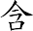   |  | 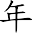





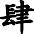



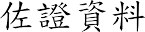

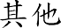


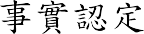

6
14  16  18
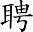


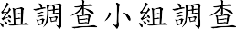
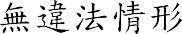



(
)




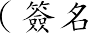
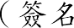


( 1 )

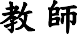




 |  |  |  |  | 
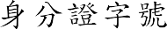
 | 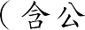 |  |   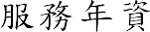




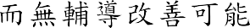


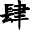



 16  1  1 
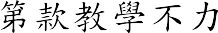

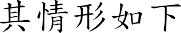

 16  1  1 

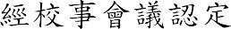 3 

2
5
18
1
16
1
1
14
6
16
18
1
16
5
3
1
15
11
8
1
14
